**Research Environment Setup Guide**

This document provides step-by-step instructions for setting up a research environment using Jupyter Notebook, Git for collaboration, and Overleaf for collaborative editing. Each section includes screenshots to help guide you through the process.

**Table of Contents**

1. Setting Up Jupyter Notebook
   * Local Installation
   * Using Google Colab
2. Basic Git Usage for Team Collaboration
3. Overleaf Setup Guide for Collaborative Editing

**Setting Up Jupyter Notebook**

**Local Installation**

1. **Install Anaconda**:
   * Download Anaconda from the [official website](https://www.anaconda.com/download).
   * Follow the installation instructions for your operating system.



1. **Open Anaconda Navigator**:
   * After installation, open Anaconda Navigator from your applications. 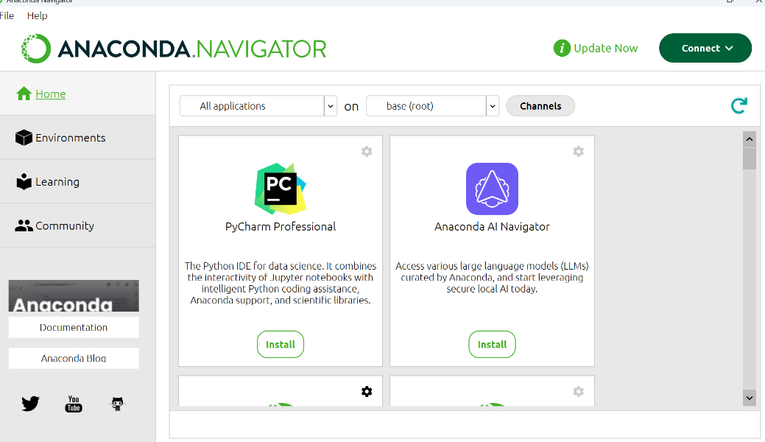
2. **Launch Jupyter Notebook**:
   * In Anaconda Navigator, click on the "Launch" button under Jupyter Notebook. 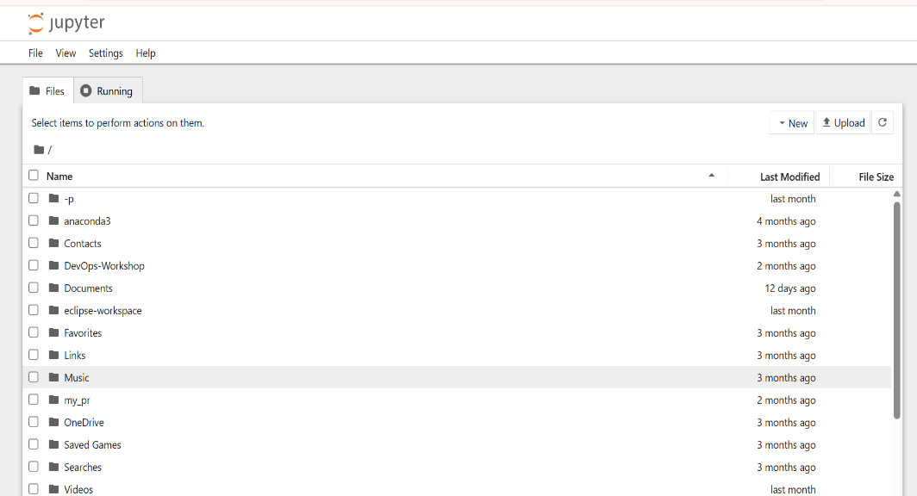
3. **Create a New Notebook**:
   * In the Jupyter interface, click on "New" and select "Python 3" to create a new notebook. 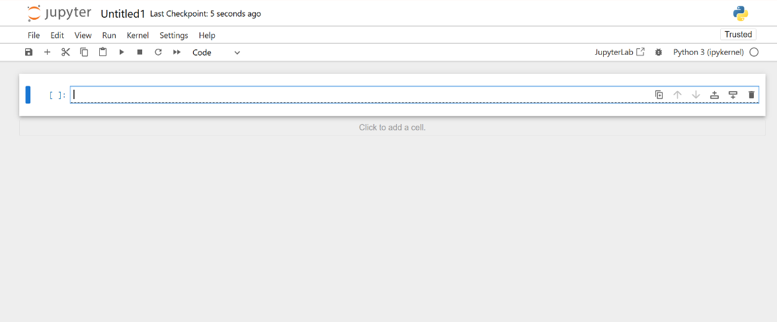

**Using Google Colab**

1. **Access Google Colab**:
   * Go to Google Colab. 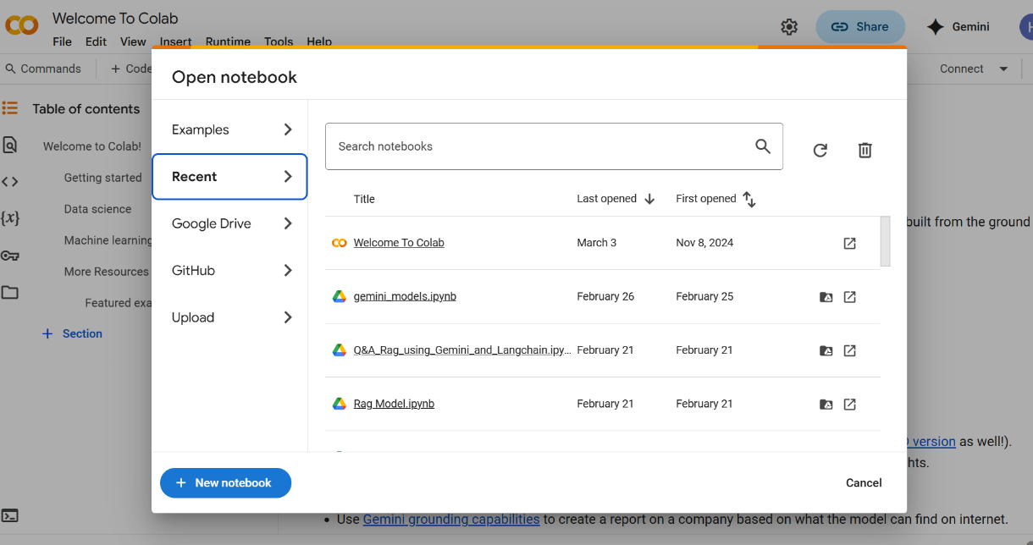
2. **Create a New Notebook**:
   * Click on "File" > "New Notebook" to create a new notebook. 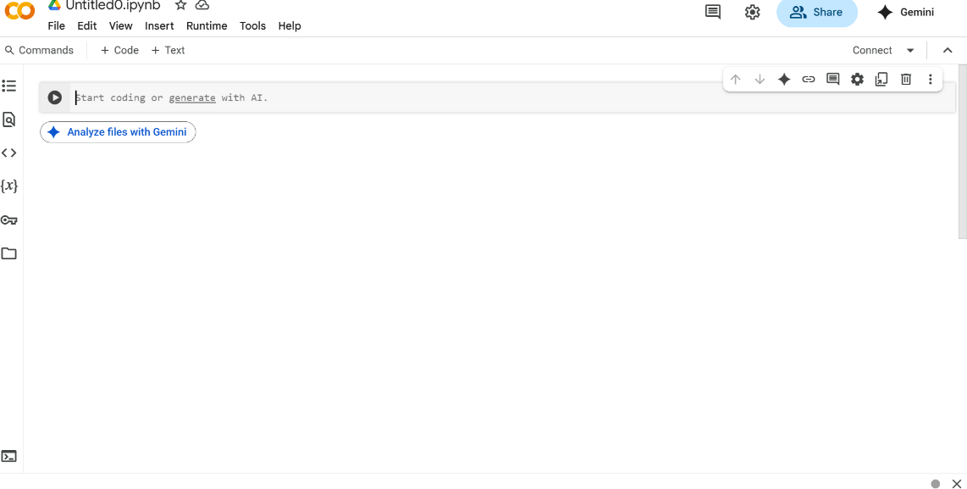
3. **Save Your Notebook**:
   * You can save your notebook to Google Drive by clicking on "File" > "Save a copy in Drive".

**Basic Git Usage for Team Collaboration**

1. Install Git:
   * Download Git from the [official website](https://git-scm.com/downloads)and follow the installation instructions.

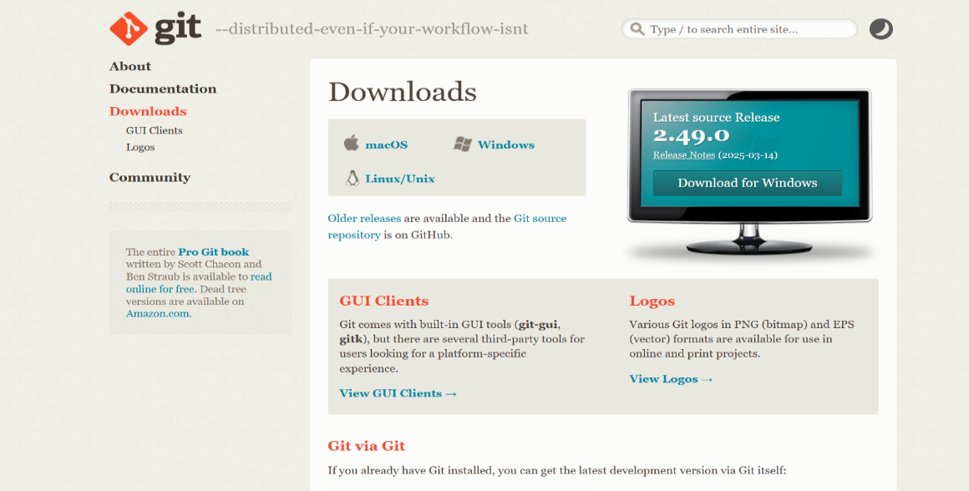

1. Clone a Repository:
   * Use the command line to clone a repository:
   * git clone https://github.com/username/repository.git
2. Create a Branch:
   * Create a new branch for your work:
   * git checkout -b feature-branch
3. Add and Commit Changes:
   * Stage your changes and commit:
   * git add .
   * git commit -m "Your commit message"
4. Push Changes:
   * Push your changes to the remote repository:
   * git push origin feature-branch
5. Create a Pull Request:
   * Go to your repository on GitHub and create a pull request to merge your changes.

**Overleaf Setup Guide for Collaborative Editing**

1. Create an Overleaf Account:
   * Go to [Overleaf](https://www.overleaf.com/) and sign up for a free account. 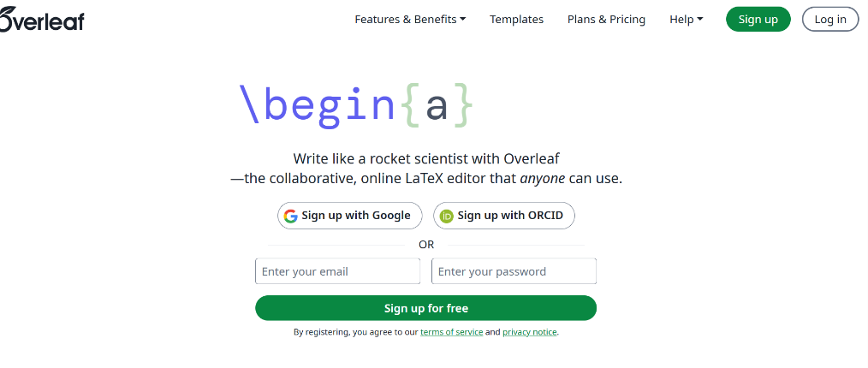
2. Create a New Project:
   * Click on "New Project" and select "Blank Project" or choose a template. 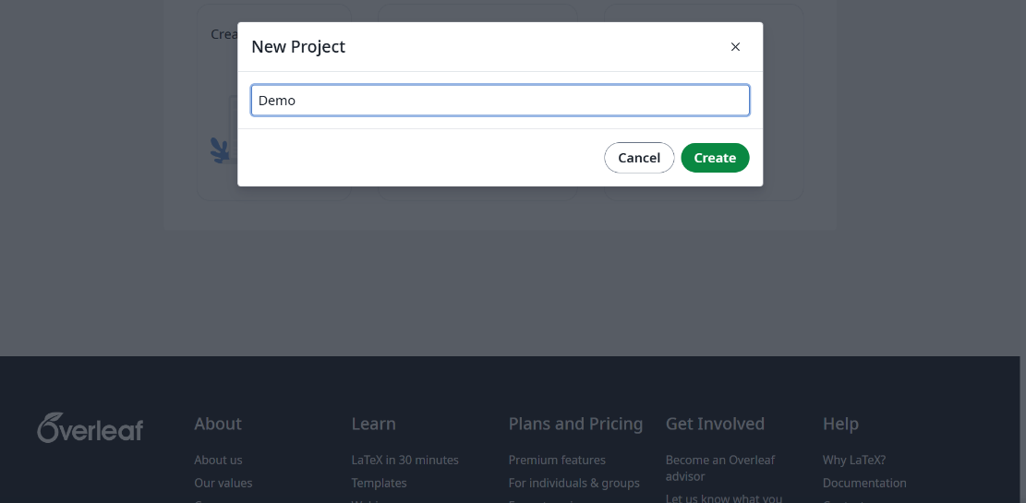
3. Invite Collaborators:
   * Click on "Share" in the top right corner and enter the email addresses of your collaborators.
4. Edit and Compile:
   * Collaborators can edit the document simultaneously. Click on "Recompile" to see changes. 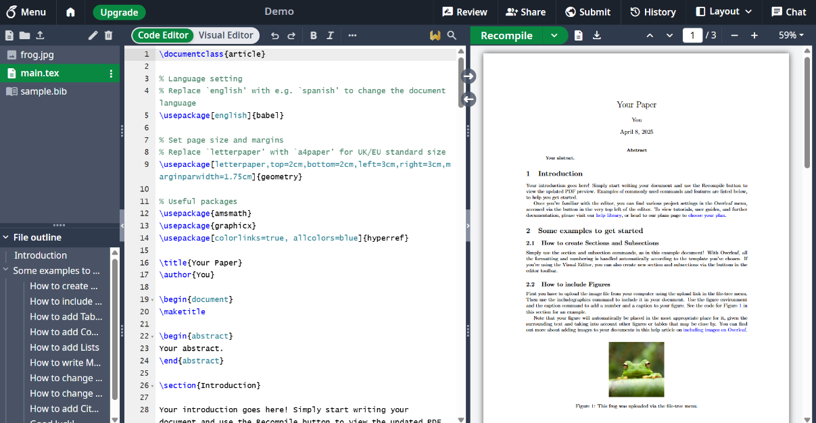
5. Download the Project:
   * Download Git from the official website and follow the installation instructions. 